Contents
1: Introduction 2
1.1 Introduction of Proposed Project 2
1.2 Problem Statement 2
1.3 Objectives 2
1.4 Scope and Limitation 3
Limitations: 4
2. Literature Review 4
2.1 Overview of Job Search Platforms 4
2.2 Key Technologies 4
2.3 Challenges in Existing Systems 4
2.4 Research Gaps 4
2.5 Conclusion 4
3. Methodology 5
3.1 Requirement Identification 5
b. Requirement Collection 5
3.2 Feasibility Study 5
3.3 High-Level Design of System 6
5. Expected Outcome 8
6. References 8

1: Introduction

1.1 Introduction of Proposed Project
The Job Search System is an innovative web-based platform aimed at bridging the gap between job seekers and employers. This system is designed to simplify the process of job searching, applying for positions, and managing job applications, all while ensuring that employers can easily post job vacancies and review potential candidates. The platform will provide a seamless and user-friendly experience, built using modern web technologies like Java Spring Boot, HTML, CSS, and JavaScript.

1.2 Problem Statement
In today’s competitive job market, the process of finding suitable jobs or the right candidates can be overwhelming and inefficient. Multiple job portals with varying interfaces and inconsistent application processes contribute to a fragmented experience for both job seekers and employers. Additionally, the lack of real-time communication and tracking capabilities further complicates the process, leading to missed opportunities and delays. This project addresses these issues by providing a unified platform that streamlines job searching, application submission, and job management, ultimately improving the overall efficiency and user experience.

1.3 Objectives
- To create a unified platform: Develop a web-based system that integrates job searching, application submission, and job posting into a single interface.
- Enhance user experience: Design an intuitive and user-friendly interface that simplifies the process for both job seekers and employers.
- Ensure security: Implement secure authentication and session management to protect user data.
- Facilitate efficient communication: Enable real-time tracking of job applications and streamlined communication between job seekers and employers.
- Deliver value: Provide features that cater to the needs of both job seekers and employers, ensuring that the platform meets their expectations and requirements.

1.4 Scope and Limitation
The scope of this project includes the development of a job portal with core functionalities such as user registration, job searching, application submission, and job posting management.

a. User Registration and Authentication:
- User Registration: Implement basic user registration where job seekers and employers can create accounts.
- Login/Logout: Include simple login/logout functionality, focusing on one role at a time, such as job seekers initially.
- Password Management: Implement basic password reset functionality, like sending a reset link to the user's email.

b. Job Search Functionality:
- Basic Job Search: Allow job seekers to search for jobs by title and location.
- Job Listing Display: Display job listings in a simple, paginated format. Each job should show basic details like title, company, and location.

c. Job Posting (Employer-Side):
- Employer Job Posting: Employers can post jobs, specifying basic information such as job title, description, and location.
- Simple Dashboard: Create a basic employer dashboard where they can see a list of their posted jobs.

d. Application Submission:
- Apply for Jobs: Job seekers can submit their applications by uploading a resume. Store this information in a simple database table.
- Application List: Job seekers can view a list of the jobs they've applied for.

e. User Interface:
- Simple and Clean UI: Use Thymeleaf to create a straightforward interface. Focus on usability rather than complex design.
- Responsive Design: Implement basic responsive design so the application works well on desktops and mobile devices.

f. Security and Privacy:
- Basic Security: Implement basic security features such as encrypting passwords and protecting sensitive pages with authentication.

Limitations:
- No Advanced Features: Skip advanced features like role-based access (focus on job seekers first) or third-party integrations.

- Minimal Analytics: No analytics or reporting features for employers. Keep the focus on core functionalities.

- No Machine Learning: Does not include AI or machine learning features like job recommendations or matching algorithms.

2. Literature Review

2.1 Overview of Job Search Platforms
- Early job portals like Monster.com provided basic job listings, while modern platforms like LinkedIn and Indeed offer more advanced features, such as job recommendations and integration with social media.

2.2 Key Technologies
- Spring Boot is popular for building backend systems due to its simplicity.
- Thymeleaf is used for creating dynamic web pages.
- MySQL and PostgreSQL are common databases for storing user and job data.

2.3 Challenges in Existing Systems
- Scalability: Managing a large number of users and jobs can be challenging.
- User Experience: Many platforms struggle with making their interfaces user-friendly.
- Security: Protecting user data is a major concern for all job platforms.

2.4 Research Gaps
- Personalization: There is still a need for better job matching.
- Accessibility: Many platforms need to improve how they serve users with disabilities.

2.5 Conclusion
Understanding these aspects helps in designing a job search system that is simple, secure, and user-friendly.

3. Methodology

3.1 Requirement Identification

a. Study of Existing System
A detailed analysis of existing job search platforms, such as Indeed, LinkedIn, and Glassdoor, will be conducted to identify their strengths and weaknesses. This study will focus on features like user interface, search functionality, application tracking, and communication tools. The insights gained from this analysis will guide the development of the Job Search System, ensuring that it addresses the gaps in existing solutions.

b. Requirement Collection
Requirements will be gathered through surveys, interviews, and focus groups involving potential users, including job seekers and employers. The collected requirements will include both functional and non-functional aspects, such as user interface preferences, security expectations, and performance standards. This information will form the basis for the design and development phases of the project.

3.2 Feasibility Study

a. Technical Feasibility
The system will be developed using Java Spring Boot for the backend, ensuring scalability and robustness. The frontend will be built using HTML, CSS, and JavaScript, providing a responsive and interactive user experience. The feasibility study will confirm that the chosen technology stack is suitable for the project and that the necessary technical skills and resources are available.

b. Operational Feasibility
The Job Search System will integrate seamlessly into the existing workflows of job seekers and employers. User acceptance testing (UAT) will be conducted to ensure that the system is user-friendly and meets the operational needs of its intended users. The study will also evaluate the system's ability to scale as the user base grows.

c. Economic Feasibility
A cost-benefit analysis will be performed to assess the financial viability of the project. This will include estimating the development, deployment, and maintenance costs, and comparing them with the expected benefits, such as increased efficiency, user satisfaction, and potential revenue generation through premium features or advertisements.

3.3 High-Level Design of System

a. System Flow Chart
A system flow chart will be created to visually represent the major processes within the Job Search System, such as user registration, job searching, application submission, and job posting management. This chart will illustrate how data flows through the system and how different components interact.
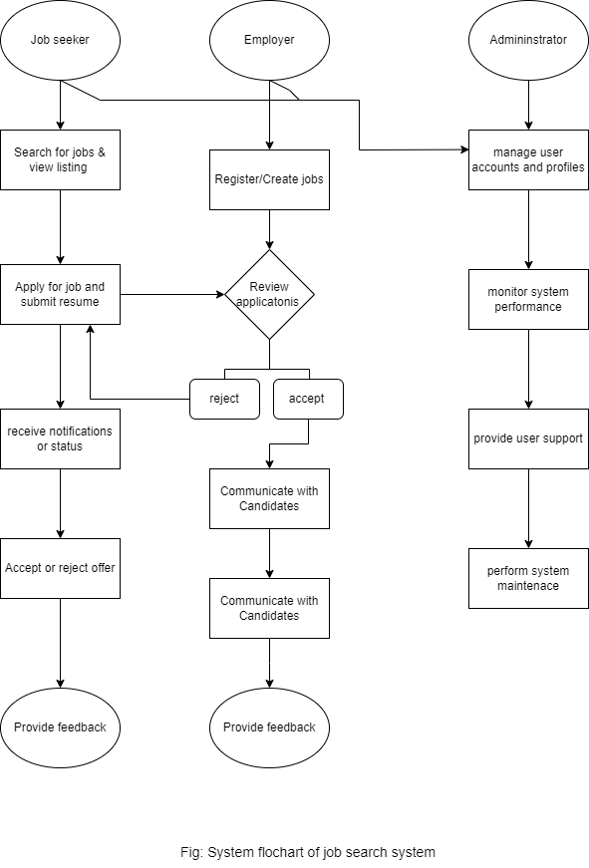

Methodology: Waterfall Approach
Using waterfall methodology for this project. This approach involves completing each project phase sequentially. Here’s a brief overview of the process:
- Project Planning: Define the project’s goals and plan the overall approach.
- Requirement Gathering: Collect and document all project requirements.
- System Design: Create the system architecture and design.
- Backend Development: Build the server-side components based on the design.
- Frontend Development: Develop the user interface that interacts with the backend.
- Integration: Combine the frontend and backend components and ensure they work together.
- Testing: Test the system to identify and fix any issues.
- Deployment: Release the system to the production environment.
- Final Review and Launch: Review the project, make final adjustments, and officially launch it.
This methodology ensures a structured and systematic approach to completing the project.
4. Gantt Chart
A Gantt chart will be provided to outline the project timeline, including key phases such as:
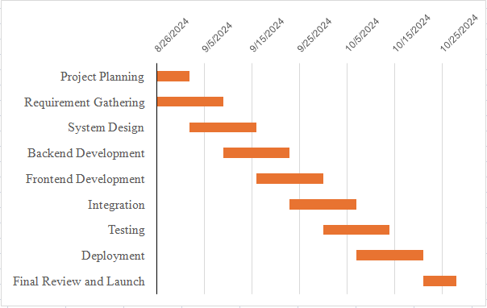

Fig: Gantt Chart of Job Search System

Each phase will have specific start and end dates, along with dependencies to ensure that the project stays on schedule.

5. Expected Outcome
The expected outcome of the project is a fully functional Job Search System that effectively serves both job seekers and employers. The system aims to streamline the job search and application process, making it easier and more efficient for users to find and apply for jobs. It should also enhance user satisfaction by providing a user-friendly interface, reliable performance, and essential features like job search, application submission, and job posting. Additionally, the system will be designed with scalability and security in mind, allowing for future growth and ensuring the protection of user data.

6. References

Online Resources
- Spring Boot Documentation. (2024). Official Documentation. Retrieved from https://docs.spring.io/spring-boot/docs/current/reference/htmlsingle/
- Java Tutorials. (2024). Official Java Tutorials. Retrieved from https://docs.oracle.com/javase/tutorial/
- PostgreSQL Documentation. (2024). PostgreSQL Official Documentation. Retrieved from https://www.postgresql.org/docs/
- Stack Overflow. (2024). Developer Forum. Retrieved from https://stackoverflow.com/

